SHRIMP DISEASES AND REASONS:

VIBRIOSIS:
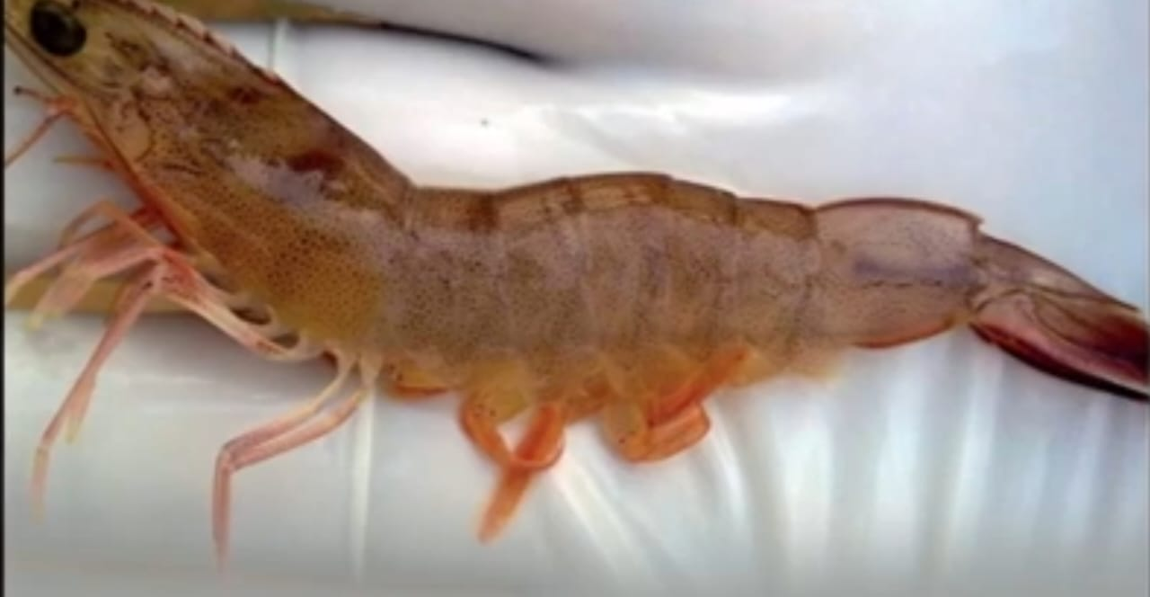
* The Disease Is Infected To Shrimp Due To Bacteria called VIBRIO.
* The disease infected through vibrio is called vibriosis
REASONS:
1. Environmental factors
2. Water parameters [Shrimp Parameters of pond]
3. Having more number of vibrio is called vibrio load
Vibrio Contains Of two products:
1.Enzymes :
* Protolytic Enzymes
* Kytolytic Enzymes
2.Toxins
VIBRIO:
Natural habitat is salt water
Opportunistic pathogen
Normal flora of shrimp
Produces toxins, proteo

Localised Vibrio: This Is Related To Shell
* Black Or Brown Spots On The Shell
* Gills Will Be Changed To Brown

Systemic Vibrio: This Is Related To Hepatopancreas
*Red Spots On The Hepatopancreas

White Muscle In The Shrimp Can Be Seen In The Shrimp And It Is Caused Due To The Vibriosis

OTHER SYMPTOMS:
1. Low Feeling
2. Lathergic
3. Swin On Surface Of Water
4. Reaches To Banks
PRECAUTIONS FOR VIBRIO:
*All Ponds Have Some Amount Of Vibrio
* Pond Bio Physical And Chemical Properties Influence Vibrio
1. Good Seed Quality
2. Vibrio Testing Before Stocking
3. Vibrio Testing For Every 7 Days
4. PH Management
5. Blue Green Algae Control

WHITE SPOT SYNDROME VIRUSES[WSSV]:

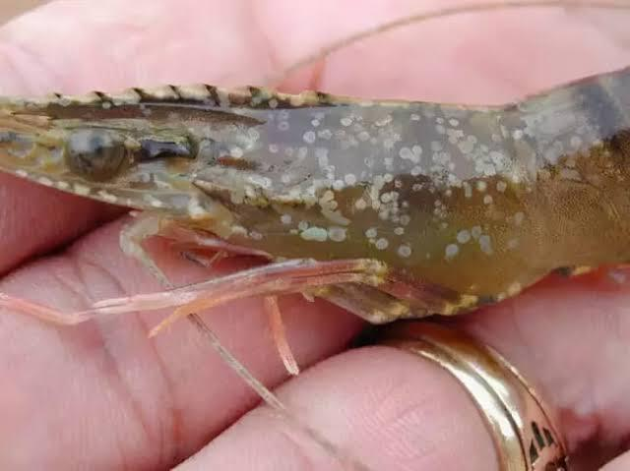
*A large double-stranded DNA virus.
* It Creates High Amount Of Mortality
* It Damages Major Glands Or Organs Of The Body
Reasons For WSSV:
* WSSV Is Caused From The Mother Shrimp To The Other Shrimp
* It Is Also Transmitted From The Other Ponds

How To Know Whether The Shrimp Is Affected With WSSV:
*By Seeing [Assumption]

*Clinical Diagnosis
PCR (Polymerase Chain Reaction) — most accurate method
Histopathology — reveals infected tissues under a microscope
Electron Microscopy — shows rod-shaped virus particles Rapid Test Kits — used for on-site detection

Symptoms:
* Stop Taking Feed
* Shrimp Starts To Float On Water
*Mass No.of Shrimps Come To The Banks Of The Pond
*Shrimp Mostache [రొయ్య మీసం] Turns Red
* Majorly We Can Recognize The White Spots On The Shrimp

